**Design Model of CC Event Recommendation system**

Algorithm:

We have used content-based filtering algorithm which tries to recommend items to users based on their profile. The user’s profile has a domain and event he/she is interested in and based on the algorithm we will recommend the user for a particular event.

Working:

Initially company will have user’s data with it which contains domain name and event he/she Is interested in, after that whenever an event comes to the company, the company with this model will try to predict all those profiles which will have some interest in it.

In this way we try to save lot of time as well as resources of the company and thus in a way help grow more people in the company

Representation is as follow

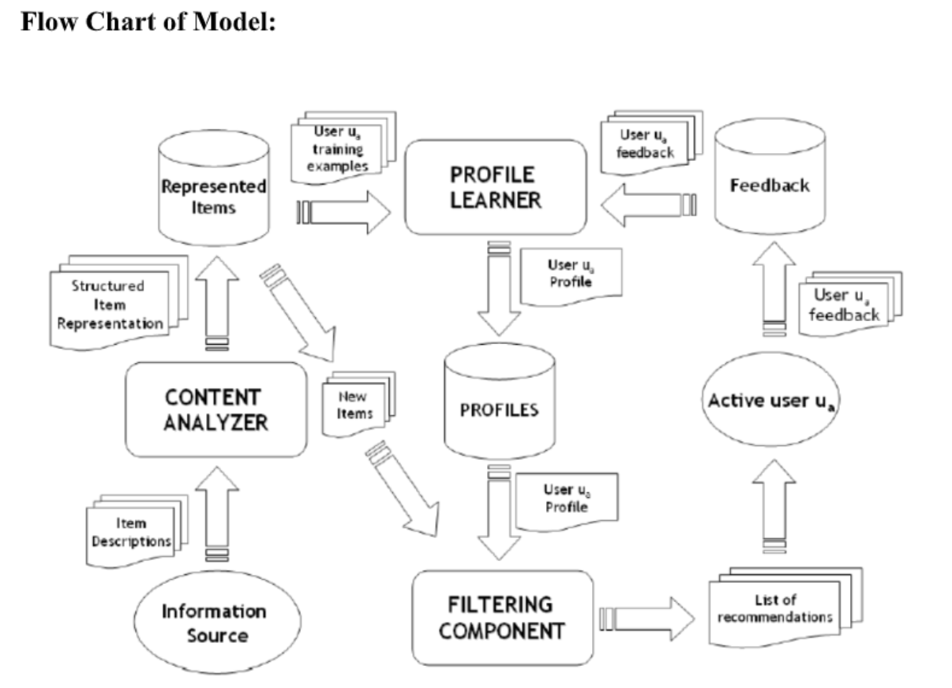

Architecture:

Users: The Manager or the HR or a person who manages the particular task.

Data: The data of employees/ intern with their domain and their preferences of

events.

Application: To classify the employees on the basis of their preferences to a event.